Recruitment Feedback
CLIENT REFERNCE :
URL : https://dra.elitehrms.com
User Name : 0066
Password : Joan@2012
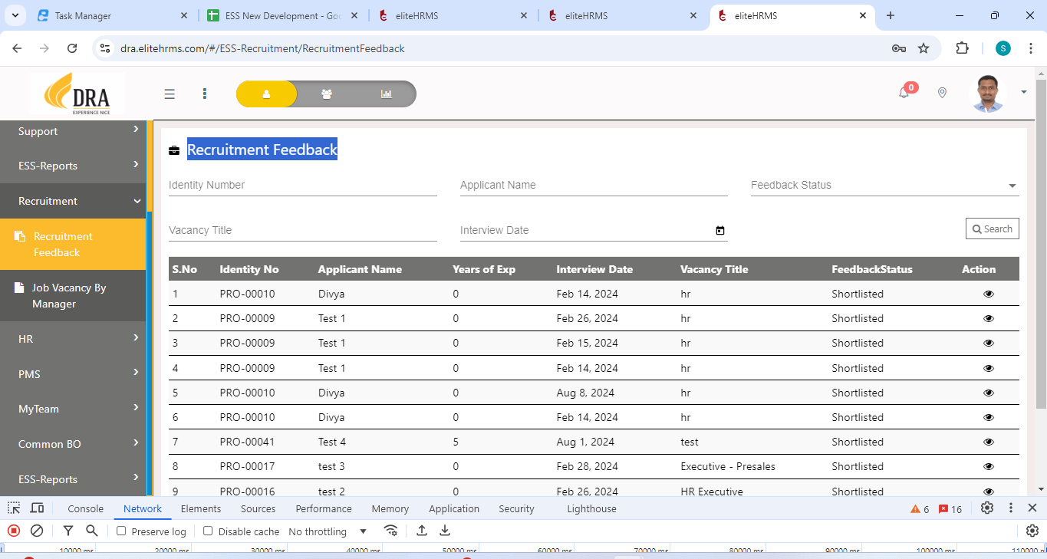
- Need to change Search Page.
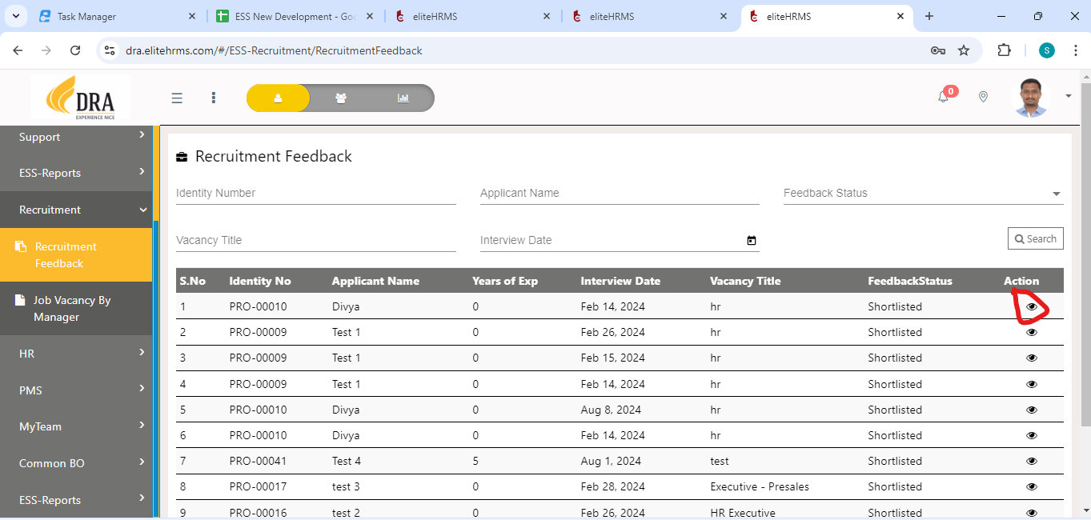
- In Edit Mode need to call “GetRecruitmentFeedBackData”
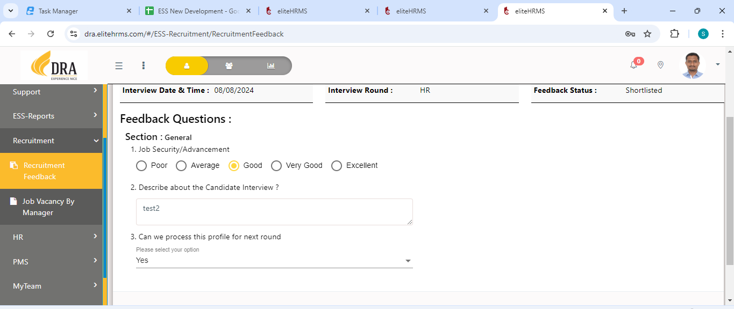
- In Answer type drop down need to call “GetCommonRefVal”.

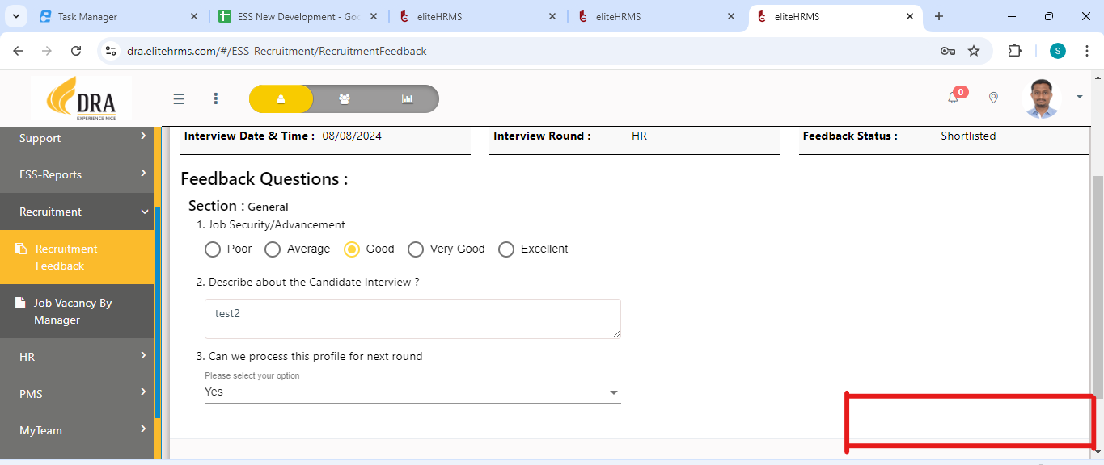
- Marked place Hold, Shortlist, Reject button showing in Post api need to send above button id to send in dynamic.
- All data to eneter click any one button to call “PostRecruitmentFeedBack”
Post Api :
https://localhost:44349/api/Personal/PostRecruitmentFeedBack
{
"RecFeedbackListDetailInfo": [
{
"EmpFeedBackGUID": "058367f0-738d-437b-a359-250dd7d5d17d",
"ProfilesGUID": "058367f0-738d-437b-a359-250dd7d5d17d",
"Date": "2024/02/14",
"IdentityNo": "PRO-00009",
"ApplicantName": "Test 1",
"VacancyTitle": "hr",
"InterviewScheduleDate": "2024/07/06",
"YearsofExp": 0,
"Round": null,
"Feedbackcode": "FBT-0001",
"FeedbackStatus": "Initiated",
"FeedbackStatusID": "1852",
"ShortlistStatus": null,
"InterviewRound": "Manger Round"
}
],
"RecQuestionDetailsInfo": [
{
"SessionID": 2770,
"Session": "General",
"QuestionGUID": "2499e010-e91d-4adc-8348-5c3246d0bd4d",
"QuestionName": "Can we process this profile for next round",
"AnswerType": "Multi Chosen",
"AnswerTypeID": 564,
"Answer": "f27c50a8-43d5-46f2-95a6-2b987887c8ce",
"Mandatory": "Yes",
"Sequence": "1",
"AnswerList": [
"f27c50a8-43d5-46f2-95a6-2b987887c8ce"
],
"option": [
{
"OutputStrValue": "f27c50a8-43d5-46f2-95a6-2b987887c8ce",
"OutputStrLabel": "Yes"
},
{
"OutputStrValue": "3de4afe1-8e7d-4798-8d41-f92782105689",
"OutputStrLabel": "No"
},
{
"OutputStrValue": "805b5bfe-8824-42bb-8ca3-df24a6595e83",
"OutputStrLabel": "Hold"
}
]
},
{
"SessionID": 2770,
"Session": "General",
"QuestionGUID": "050eff98-c16f-4df6-88b8-05af82c39325",
"QuestionName": "Job Security/Advancement",
"AnswerType": "Chosen",
"AnswerTypeID": 563,
"Answer": "d97f2c4b-1944-4a85-826a-06a56a81a953",
"Mandatory": "Yes",
"Sequence": "1",
"option": [
{
"OutputStrValue": "d569c18c-fc21-4361-b638-ff188e232bc7",
"OutputStrLabel": "Poor"
},
{
"OutputStrValue": "132115f3-08d9-4bca-a8e3-265feeccf926",
"OutputStrLabel": "Average"
},
{
"OutputStrValue": "d97f2c4b-1944-4a85-826a-06a56a81a953",
"OutputStrLabel": "Good"
},
{
"OutputStrValue": "a09ff369-0dde-40e1-a80f-60e9db39d464",
"OutputStrLabel": "Very Good"
},
{
"OutputStrValue": "124a537e-00f8-4216-a101-1fdb24937e23",
"OutputStrLabel": "Excellent"
}
]
},
{
"SessionID": 2770,
"Session": "General",
"QuestionGUID": "331eaa4b-bf5c-48df-809f-51611999cbb2",
"QuestionName": "Describe about the Candidate Interview ?",
"AnswerType": "Free Form",
"AnswerTypeID": 562,
"Answer": "good",
"Mandatory": "Yes",
"Sequence": "1",
"option": []
}
]
}
{
"Response": {
"_status": "Success",
"_code": "111",
"_Source": "PostEmployeeFeedBack",
"_Description": "Employee feedback updated successfully",
"_Details": "",
"_TransID": null,
"_Timestamp": "20241005043831"
},
"ScreenID": 0,
"RecFeedbackListDetailInfo": [],
"RecQuestionDetailsInfo": []
}
https://localhost:44349/api/Personal/GetRecruitmentFeedBackData?ProfilesGUID=3312976A-BDEA-0636-64EB-267352547AE2
{
"Response": {
"_status": "Success",
"_code": "111",
"_Source": "GetRecruitmentFeedBackData",
"_Description": "",
"_Details": "",
"_TransID": null,
"_Timestamp": "20241005044335"
},
"ScreenID": 0,
"RecFeedbackListDetailInfo": [
{
"EmpFeedBackGUID": "3312976a-bdea-0636-64eb-267352547ae2",
"ProfilesGUID": "3312976a-bdea-0636-64eb-267352547ae2",
"Date": "10/07/2024",
"IdentityNo": "PRO-00006",
"ApplicantName": "suriya",
"VacancyTitle": "Manager",
"InterviewScheduleDate": "24/07/2024",
"YearsofExp": 0.0,
"Round": null,
"Feedbackcode": "",
"FeedbackStatus": "",
"FeedbackStatusID": "5390",
"ShortlistStatus": null,
"InterviewRound": ""
}
],
"RecQuestionDetailsInfo": []
}

